OTEC/SWAC/Desalination(DS)

Avery and Wu – book (1994) “Renewable Energy From the Ocean: A Guide to OTEC”

Seems to have lots of details but dated. Access?

Bernardoni et al (2019) – Techno-economic analysis of different cycles – not locations. CC-OTEC; more detailed analysis of the heat exchangers as a critical component of the system.

From this paper:

“In both the OC-OTEC and CC-OTEC a large pipe is required to collect cold seawater from the depth of the oceans. The cold water  
pipe (CWP), is a critical component of OTEC plants because it can reach an average depth of 1000 m [5] depending on the seawater  
temperature-depth profile of the selected site; CWP diameter and thickness are constrained by stresses related to pipe weight, currents, tides, waves and storms [3]. The larger the CWP diameter is, the larger the cold seawater flowrate and thus the thermal power  
leaving the plant can be. Therefore, cold water pipe diameter is proportional to OTEC plant size. In the OC solution, large turbines  
are required because of large specific volume of low pressure seawater vapor flowing in the turbine: concerns on mechanical  
resistance of the turbine exist [3].”

“However, the main disadvantage of the closed cycle solution is that large heat transfer areas are required and since heat exchangers operate in a chemically aggressive environment (seawater), expensive materials such as titanium are required. It has been assessed that heat exchangers cost in the closed cycle solution is 25e50% of total plant investment cost [6].”

Assume as input to routine that cold-water pipe diameter is 2.5m and length of 3000m. Diameter needs checking – seems small? Warm water pipe diameter the same, length of 200 m

The estimated LCOE (269 V/MWhe) for the OTEC plant is higher than that of the other power generation technologies both fossil  
fuels based and renewables. The “Cost reduction case” is characterized by lower LCOE (ca. 237 V/MWhe) that, nevertheless, does  
not change significantly the main figure of the preliminary economic analysis. An additional cost reduction can be foreseen in case  
of reduction of engineering and project management cost caused by increasing number of installed OTEC plant.

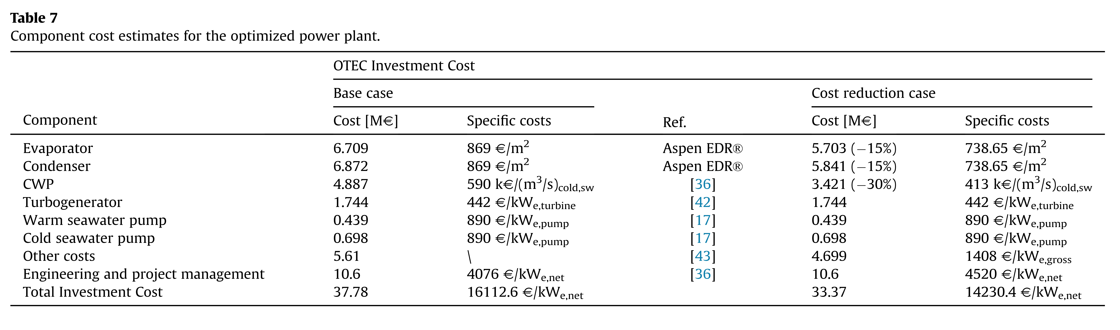

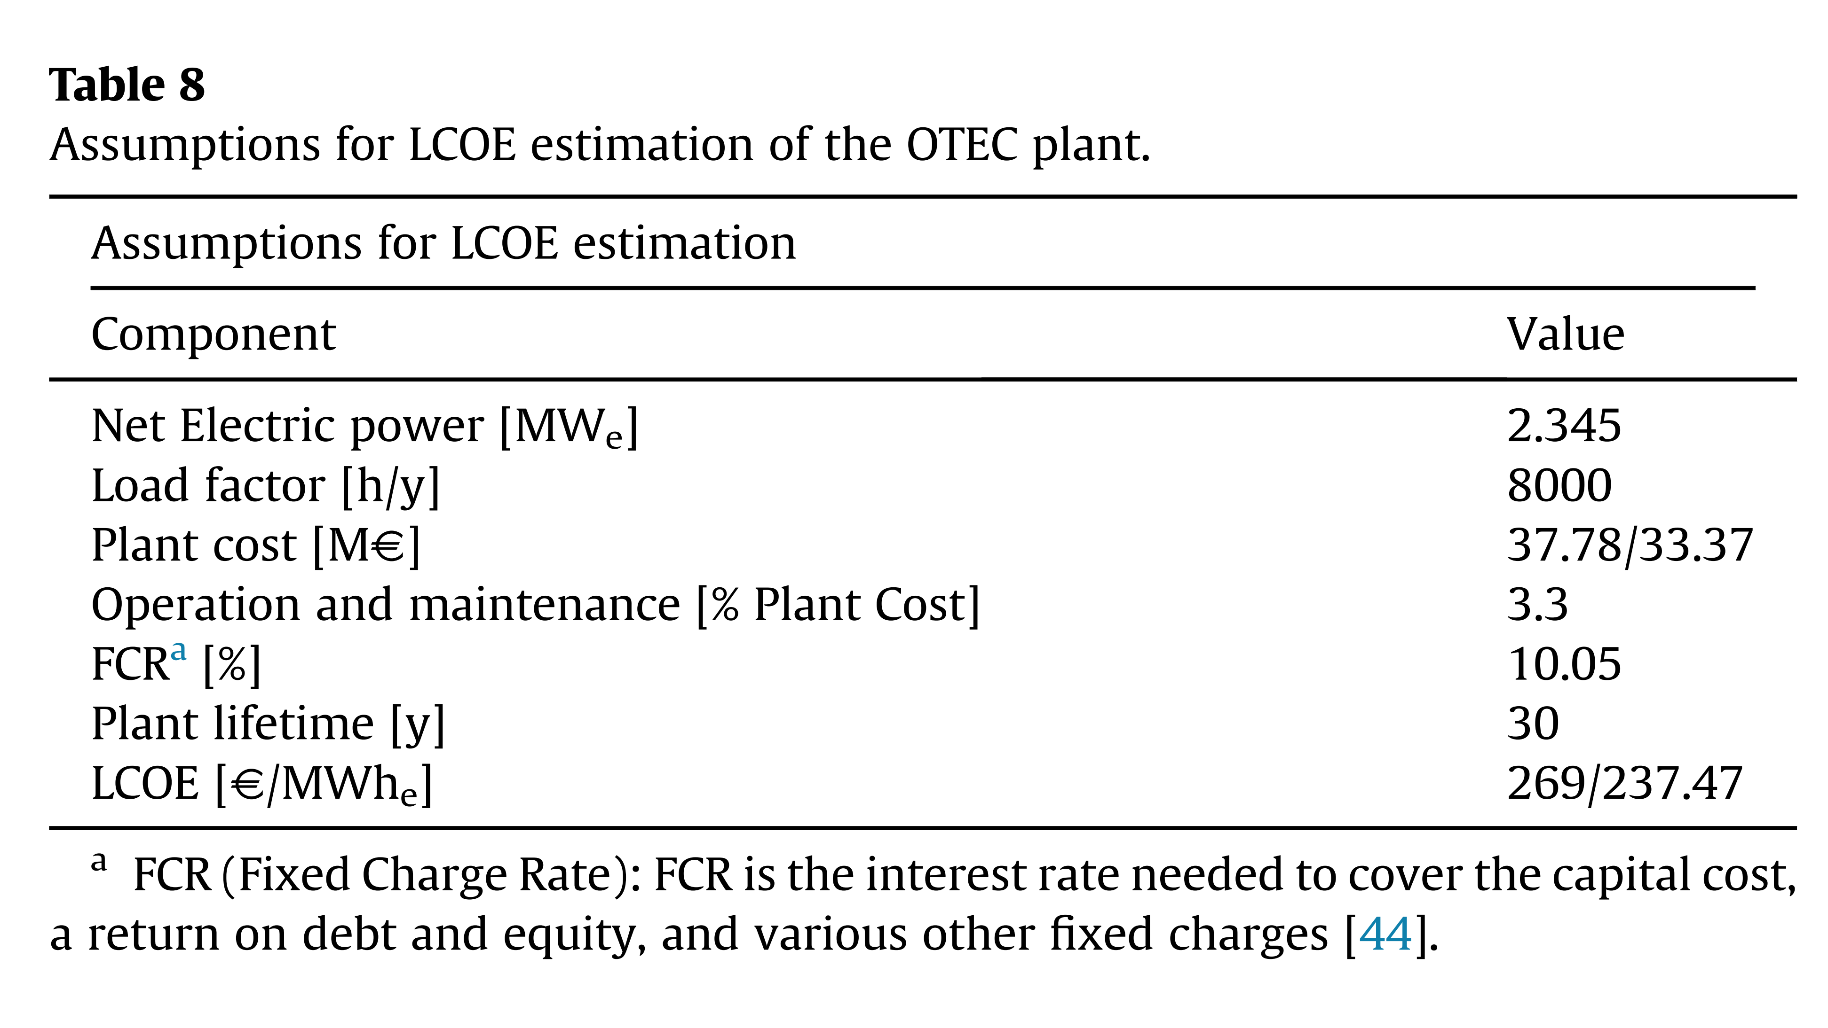

Fujita et al – short (3 pg) review from a high level of some of the history and challenges of OTEC

Henry et al. (2015) – Key factors around ocean-based power in the Caribbean – T&T playing a leading role

Look at different sources in general;

wave power – needs more research because often waves are relatively low-amplitude OTEC – the low wave amplitudes work to the advantage of OTEC; less damage to infrastructure

Hunt et al. (2019) – SWAC survey with detailed data and maps

nice overview of SWAC resource potential around the world, without considering synergies with OTEC

Map out for the world distance from coast to 5°C water depth (length of pipeline measure), then the surface temperature (percentage of hours over a certain temperature), seawater extraction depth. Create maps of various areas worldwide. Caribbean looks good, as do Pacific islands

Used GEBCO bathymetry data, 0.5 arc deg resolution (~55km)

Find many sites in the Caribbean with cooling costs of $0.02-$0.05/kWht (although figure shows $0.2-$0.5/kWht

Ikegami et al (2018) – Multi-stage Rankine cycle investigation

CC-OTEC; only technology evaluation

Many references on OTEC cycles

Khan et al (2017) – Broad overview Review of ocean energy technologies. Useful set of equations for all technologies

Kim et al (2016) – OTEC and desalination “ A byproduct of OC-OTEC is desalinated water, which is about  
0.5-0.6% by volume of the input warm surface seawater”

Discuss thermodynamics – detailed analysis that looks useful.

Modular approach of 1.8MW units to build up a larger system if needed; net power is 1.0MWel

Lots of details on system sizes

Melikoglu (2018) – global review of ocean energy resources. Not so useful, but lots of references

Mutair and Ikegami (2014) – Design optimization of desalination using OTEC. Not as useful for OTEC work. Not location specific

Nihous (2007) – preliminary assessment of OTEC resources. Estimates of global resource; also thermodynamic and hydrodynamic analysis

Nihous (2010) – Mapping OTEC resource around Hawaii. Largely limited to water temperature data

Osorio et al (2016) – combination idea for research, energy use, etc. San Andres Island, Colombia

Looks at power generation, desalination and SWAC

Park et al (2017) – hybrid solar and OTEC system – reference as interesting variant

Sinama et al (2010) – OTEC on Réunion island – relatively general overview. Focus on closed-cycle. No economic analysis

Van Zwieten et al (2017) – Assessment of Florida’s OTEC resource. Shallower water, not as interesting for my work right now

Vega (1992) – classic summary and review

Vega (2010) – updated version of above, nearly identical in content

Table 3: Assumes a 53.5MWnet plant; gives much higher costs per kW for smaller plants. However, all is done assuming a floating platform, and that the platform will cost more for an OC-OTEC system than a CC-OTEC system. Platform and mooring are about 27% of the cost; submarine power cable is 9%. Overall, platform, mooring, cable for OC-OTEC is about 48% of cost according to this result. Without that, capital cost is much less

Vega also gives “data“ for a smaller, ~5MW plant (Table 2) from two sources, one floating $35000/kW (1995) and one land-based $22800/kW (1994). Using a standard deflator, this would translate into (FRED, PPI for mfg 1995 = 120; 2020 = 200) $38000/kW today. This is significantly higher than the amount given by Bernardoni (above)

Wang et al. (2018) – organic Rankine cycle; optimization over various parameters. LCOE of $0.30-$0.50/kWh

Watt et al (1977) – OC-OTEC; very detailed early study of components, costs, etc.

Wilberforce et al (2019) – Review of ocean power technologies; generic, not terribly useful

Yeh et al. (2005) – Optimization study of CC-OTEC plant; review of earlier work in 1980s and 1990s seems fairly complete